Homework 02

Zhicheng Zhang (ZZC)

Login to AWS Educate (https://www.awseducate.com/signin/SiteLogin) and go to My Classrooms. Select Database Systems 1.

Click on AWS Console.

On the AWS Console, click on “Services” and in the Group search enter “rds” for Relational Database Services.

Click on ‘Create Database’.

Select Oracle and Oracle Enterprise Edition.

Choose Dev/Test and click on Next.

For “DB engine version” click on the drop down and select the latest patch level for Oracle 12.2.0.1.

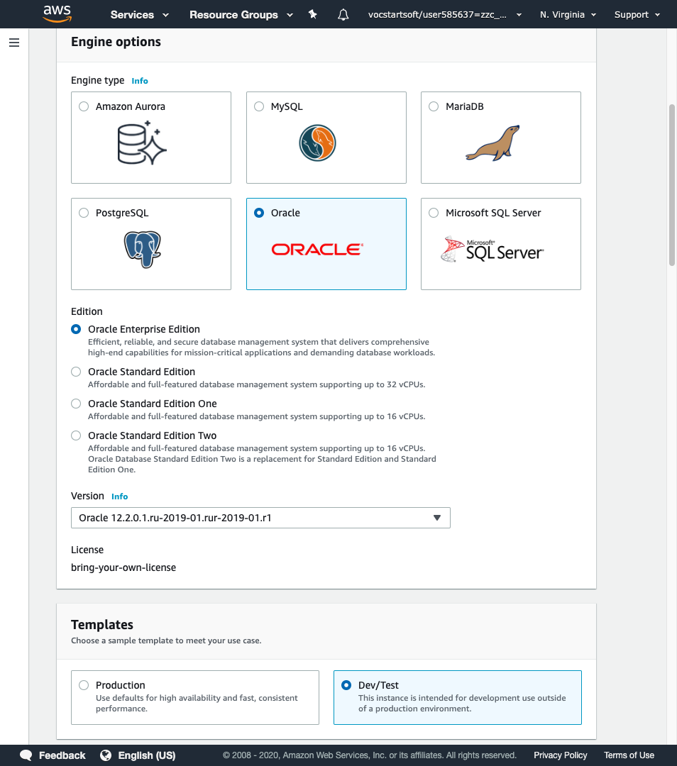

Enter a DB instance name. Example: First letter of first name + First 3 letters of last name + any number

Enter a username and password of your choice.

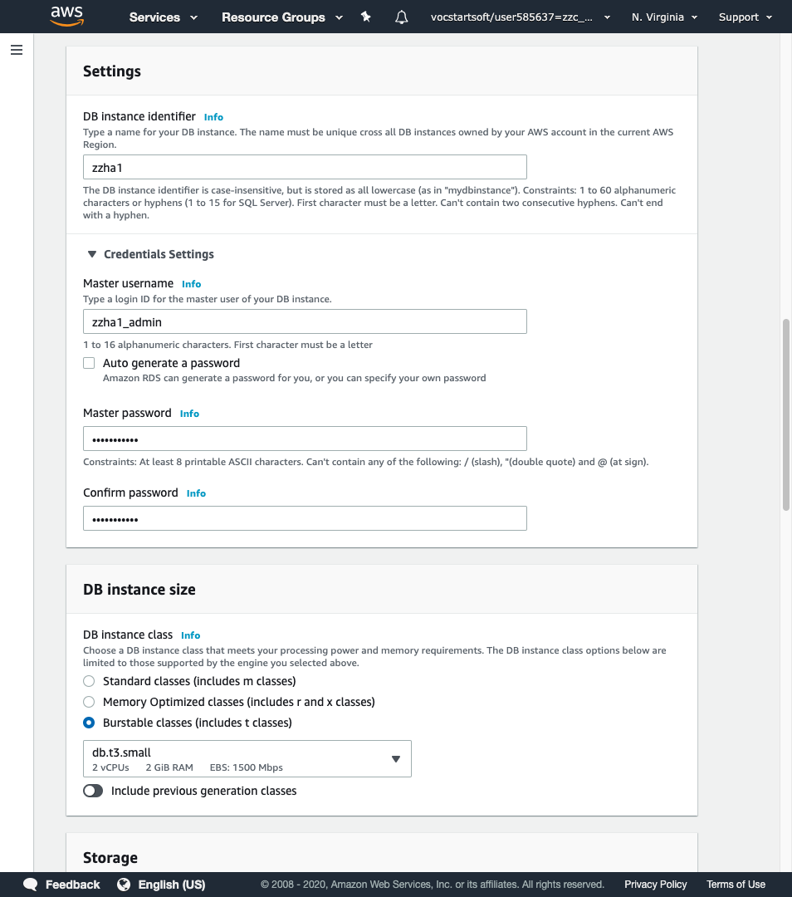

Enable Public accessibility and select availability zone.

Select ‘Create new VPC security group’.

Enter the database name same as your DB instance identifier to make it easier to remember.

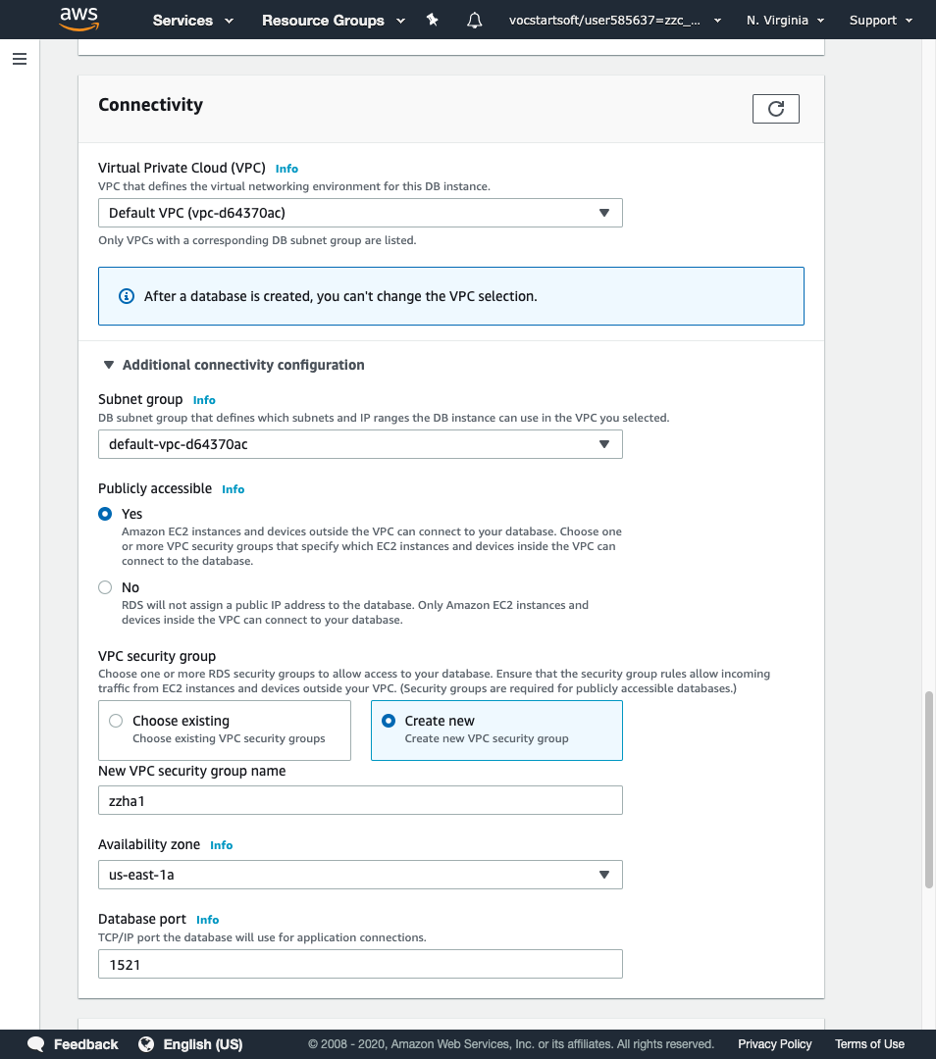

Enter the database name same as your DB instance identifier (step 8) to make it easier to remember.

Select ‘Enable enhanced monitoring’ and select all checkboxes under ‘Log exports’.

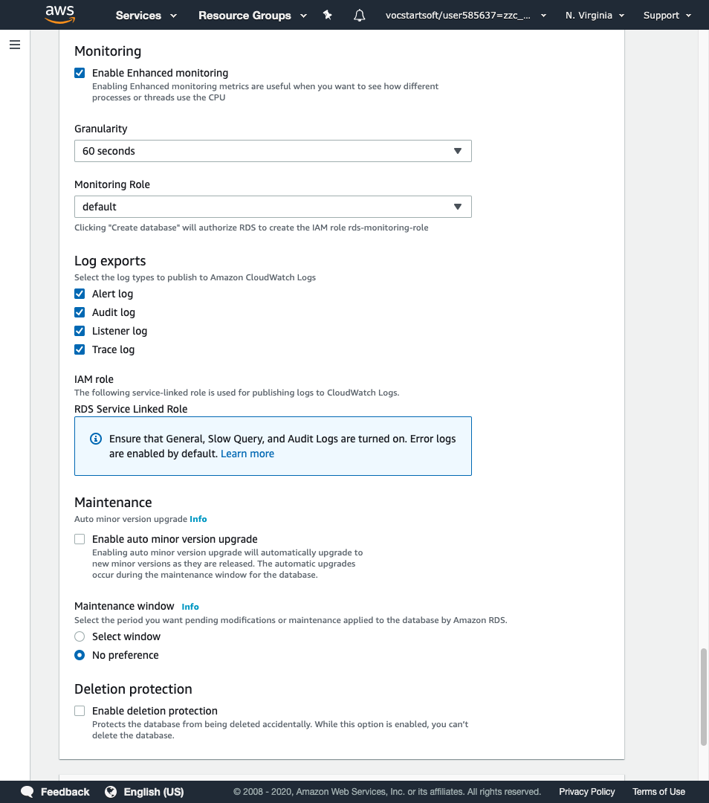

Click on ‘Create Database’.

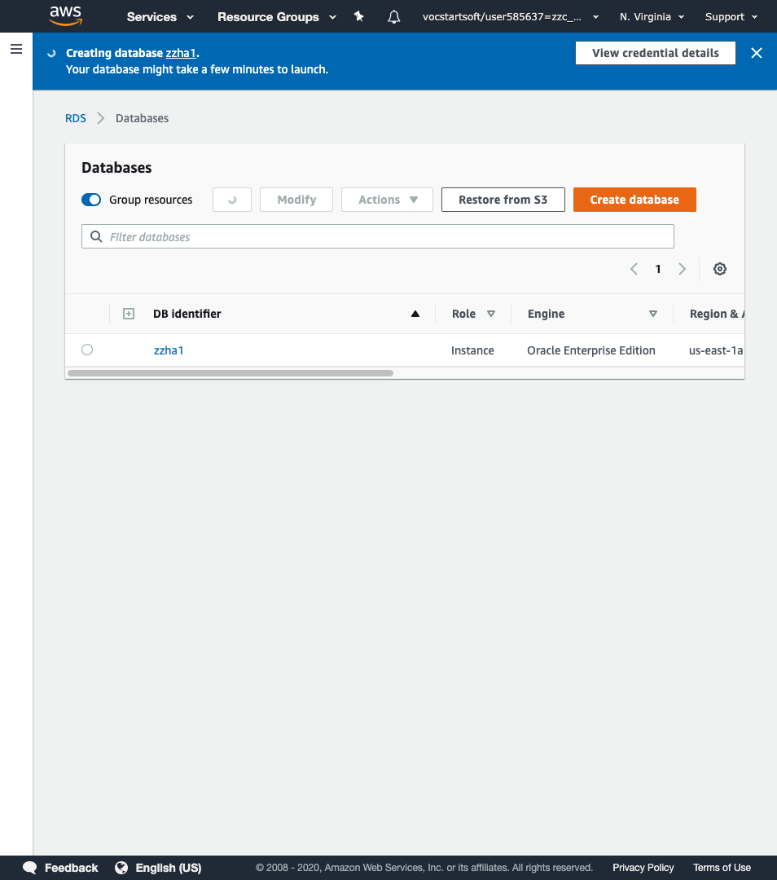

Wait until displays ‘Available’. This may take several minutes.

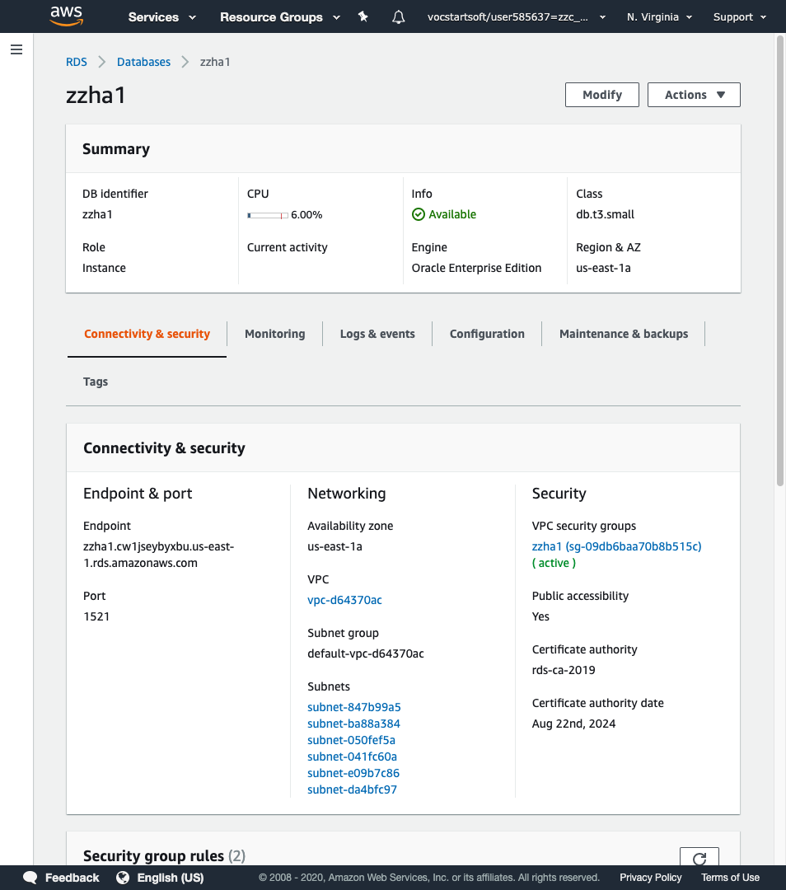

Scroll down to the security section and click on the security group name.

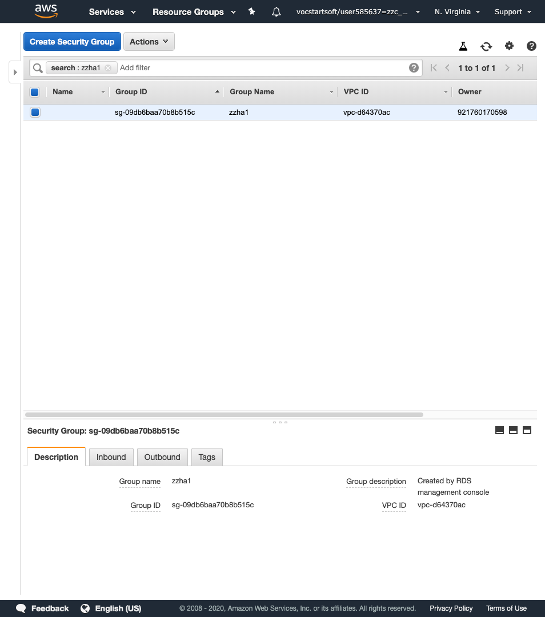

Click on Inbound and then click Edit. Make sure that your parameters match the screenshot below.

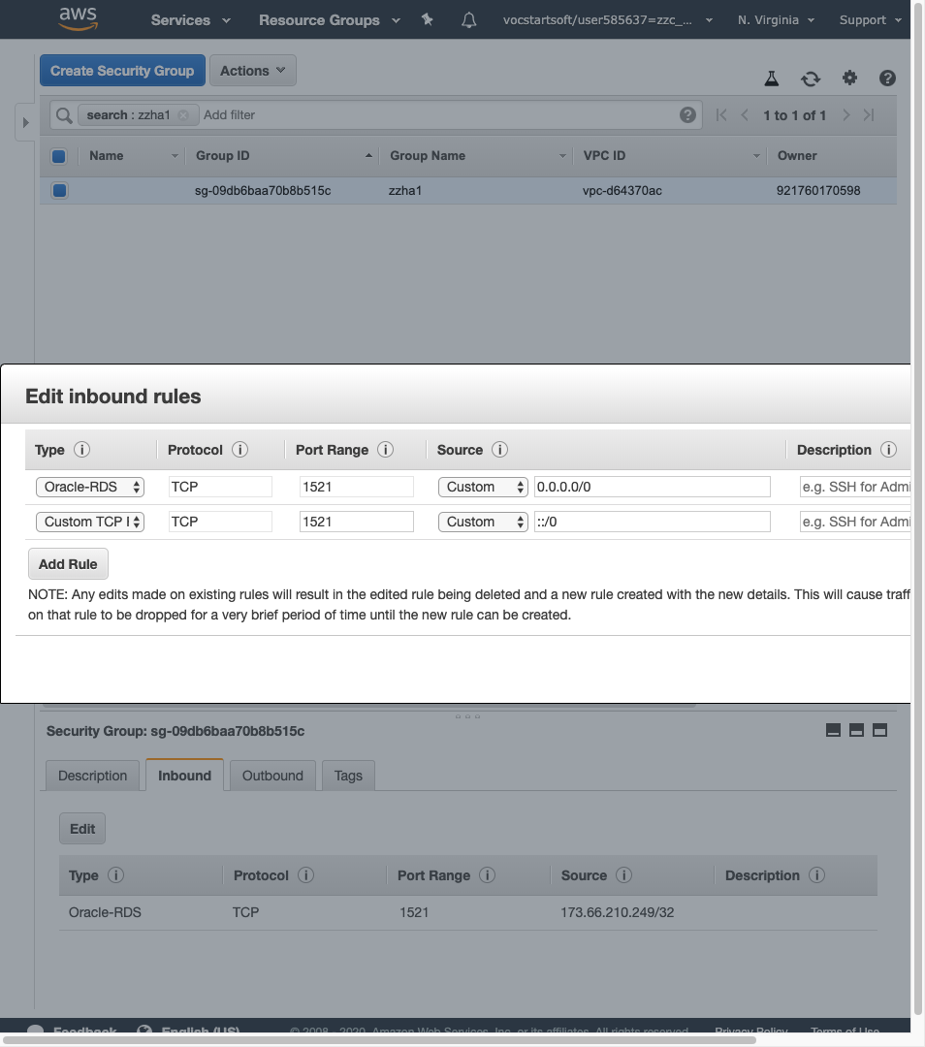

Click on Save.

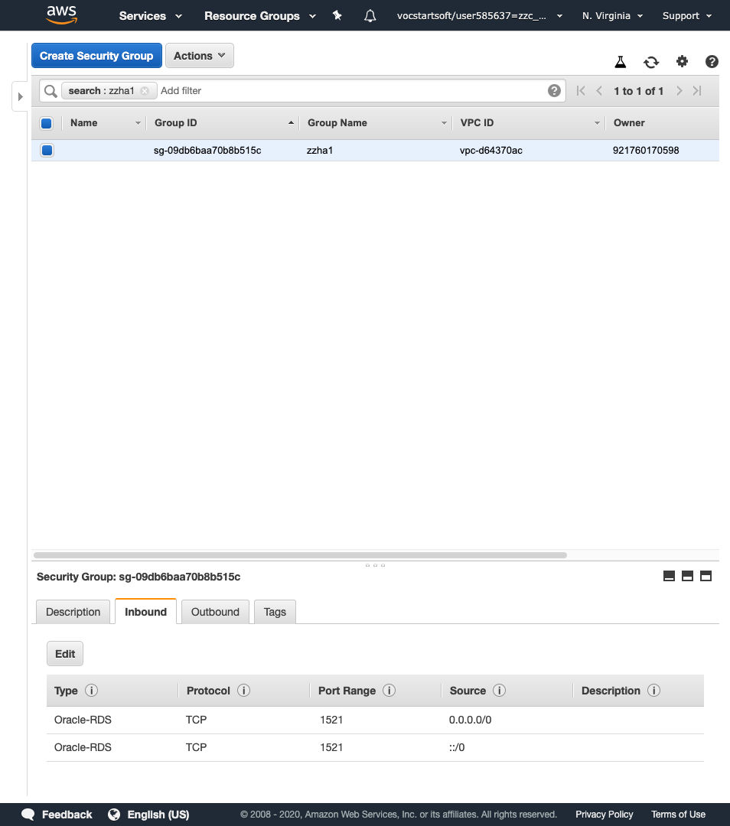

Click on Outbound and then click Edit. Make sure that your parameters match the screenshot below.

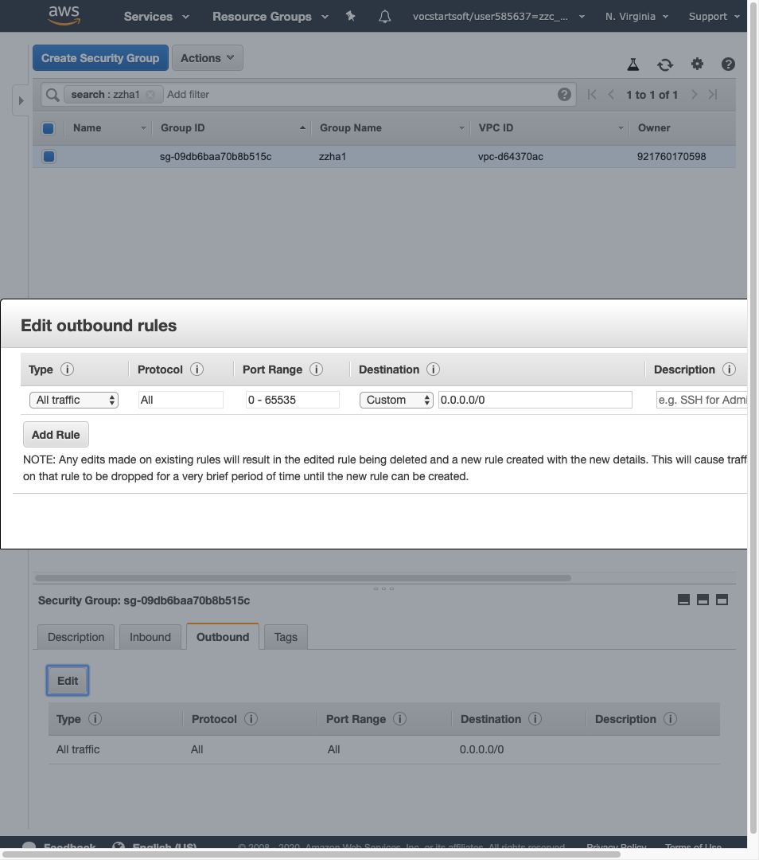

Click on Save.

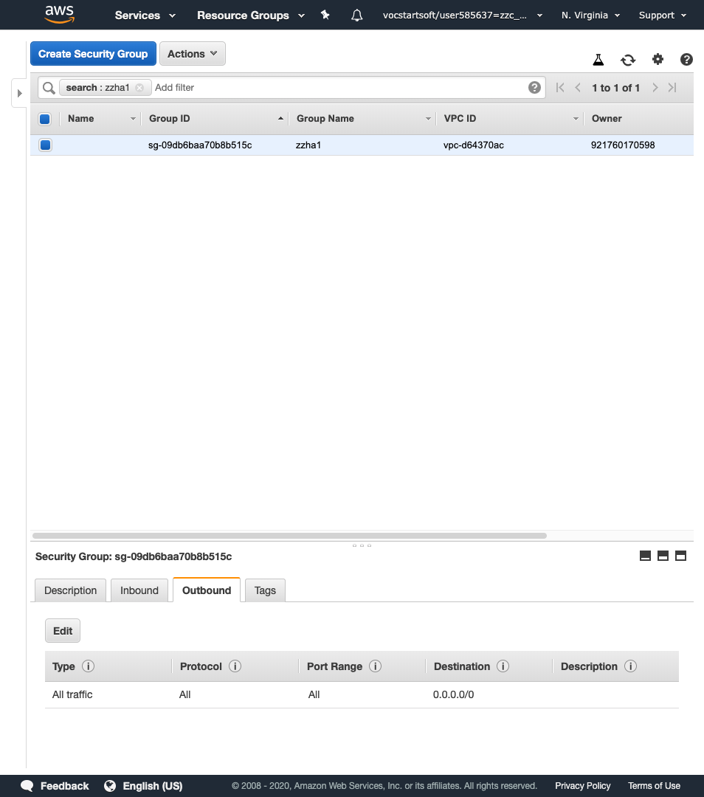

Go to RDS -> Databases. Click on the database you created.

Save the Endpoint value under ‘Connectivity’ in notepad. We will use this later.

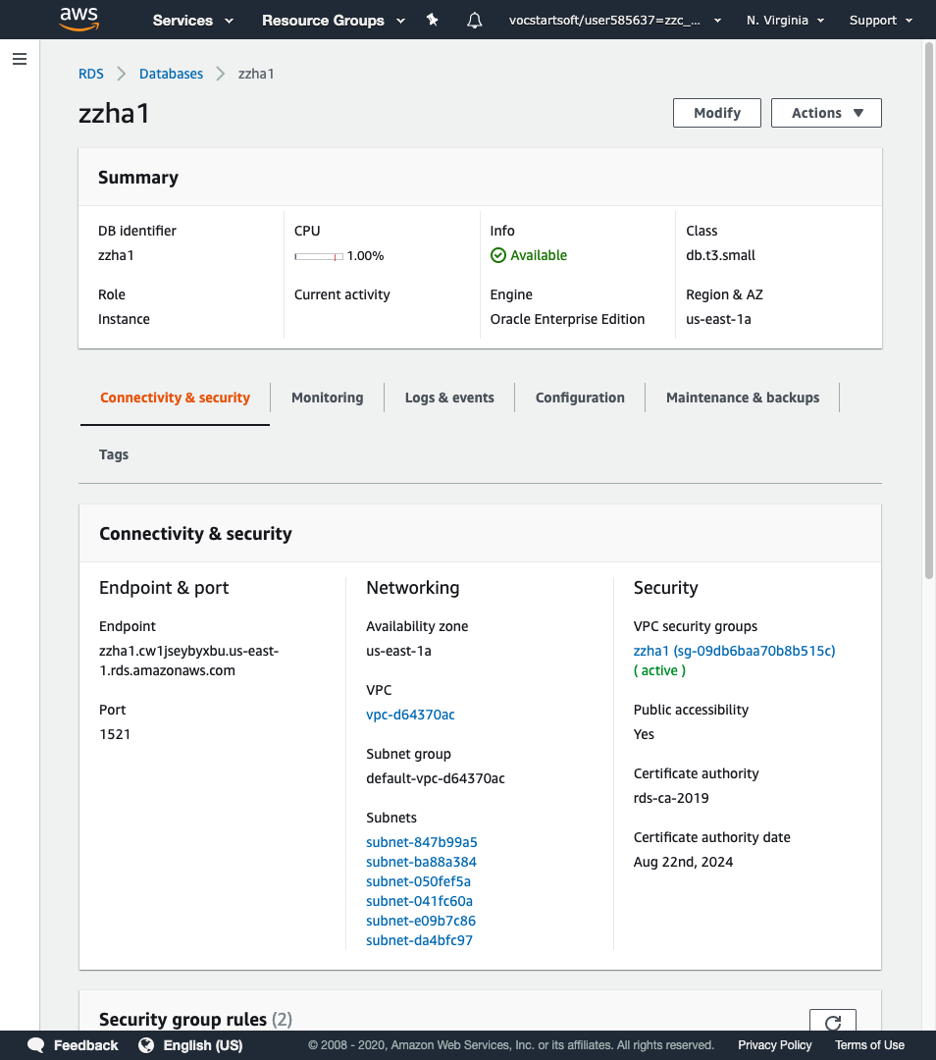

Open Oracle SQL Developer and click on New connection.

Enter the below details and click on Test. You should get ‘Success’.

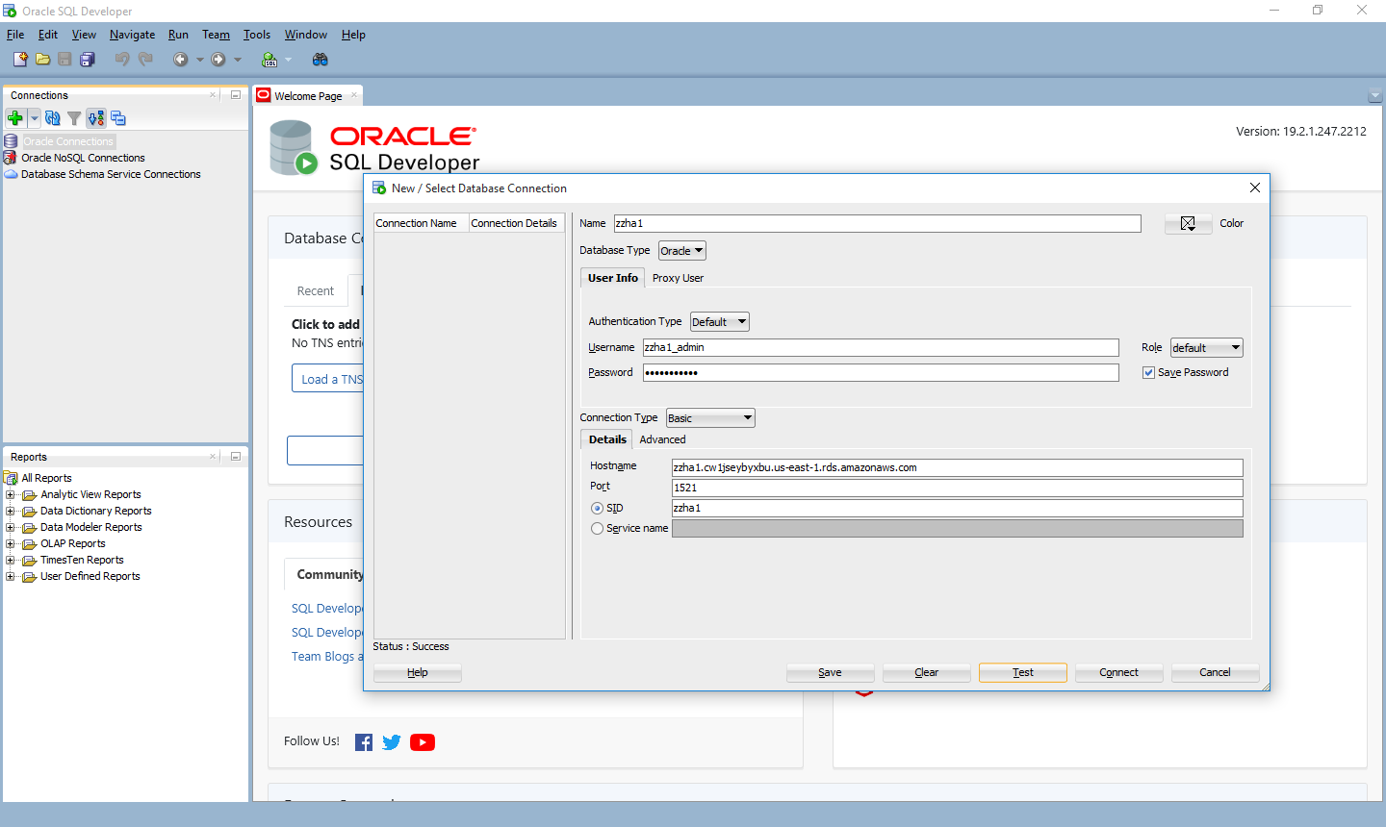

Run queries for the HR Database Schema.

Go to Datamodeler -> Import -> Data Dictionary.

Select your connection name and click on Next.

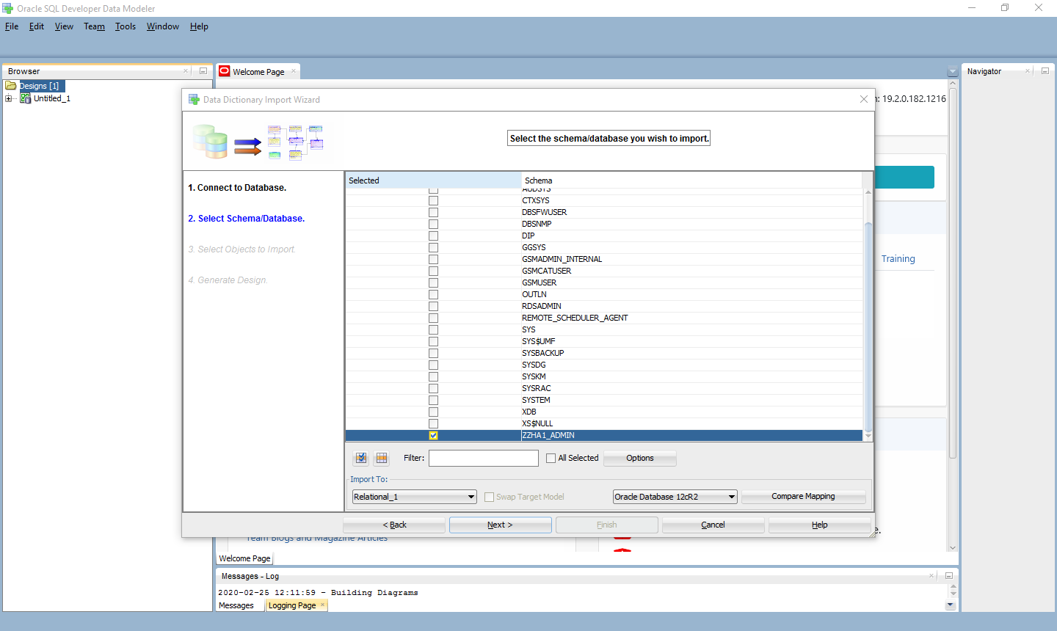

Select your user name and click on Next.

Select all the table and click on Next.

Click on Finish.

Check the log to verify that all tables were imported successfully.

This is the Relational diagram of the HR database schema.

Click on ‘Engineer to Logical Model’.

Click on Engineer.

This is the Logical diagram of the HR Database schema.

